**Research**

***Energy consumption***

*Energy Grid North*

|  |
| --- |
| **Datum : 26 apr. 2021** |
| **Versie : 1** |
| **Status : Start** |
| **Auteur : Krijgsman, N** |

# Introduction

This research is done to gather more insights on the possibilities of how to predict the energy consumption in the north.

**Introduction** **2**

**Questions and methods** **2**

How much energy is being consumed by the north? 3

What does the daily pattern look like in energy consumption? 4

Which data can be used to predict/simulate energy consumption? 5

**Conclusion** **6**

**Recommendations** **6**

**Appendix** **7**

# Questions and methods

Main: How much and when is energy used in the north?

Sub:

* How much energy is consumed by the north?
* What does the daily pattern look like in energy consumption?
* Which data can be used to predict/simulate energy consumption?

Methods:

* Library
  + Literature study (read different studies)

## How much energy is being consumed by the north?

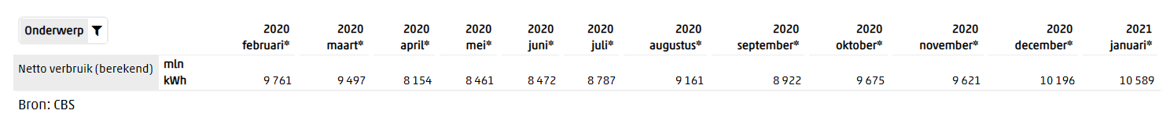

In the Netherlands there is an average monthly consumption of 9300 mln kWh. In 2014 the electricity consumption per capita was 6713 kWh. Multiply the average consumption with the number capitas in the north and that should be the consumption is the north.

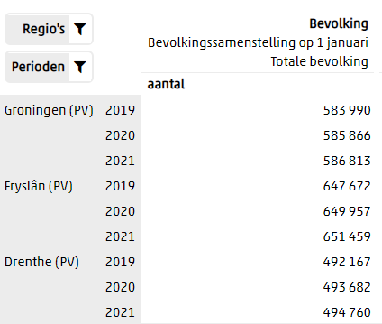

Groningen: 586813 * 6713 = 3939275669 kWh (3939 mln kWh).

Friesland: 651459 * 6713 = 4373244267 kWh (4373 mln kWh).

Drenthe: 494760 * 6713 = 3321323880 kWh (3321 mln kWh).

So yearly the amount of electricity consumed by the north is **11633 mln kWh**.

This amounts to a daily consumption of **32 mln kWh** (31871232 kWh).

## What does the daily pattern look like in energy consumption?

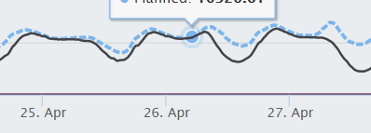

Tennet is the BPR for the Netherlands and on their dashboard of the load on the system you can find some sort of a repetition. Energy demand dips during the day from a bit past 8 oclock till 17 oclock. During the night the consumption lowers a small amount and peaks around 7.30 - 8.00. The maximum load during the last week has been **13k MW (1560 MW)**. And this dips down to around **8k MW (960 MW)** on weekdays, and dips to **5k MW (600 MW)** on weekends. The north is around **12%** of the consumption. The values between the brackets are adjusted to the north consumption.

## Which data can be used to predict/simulate energy consumption?

Simulating energy production is a hard thing to realise. There are a lot of different studies about predicting consumption. In most of these studies the researchers use a type of machine learning algorithm to predict the needs. Most of them use neural networks. Since this course is not about making our own neural network, this is not a thing we will do. Other ways of simulating the production can be just using the average consumption and have no change in that number. Or secondly try to replicate a consumption profile like in the previous question. And have the profile match the average consumption. We can have two profiles, one for weekdays and one for weekends. This might be the quickest way to simulate energy consumption.

# Conclusion

How much and when is energy used in the north?

The answer to the first part of the question is **11633 mln kWh** per year.

When the power is used is quite consistent with a major dip between 8.00 and 17.00. The depth of the dip is dependent on which type of day it is. With weekdays having a higher consumption during the dip than on weekends. The maximum consumption of the north during the last week was **1560 MW** and the dips go as low as **960 MW** (weekdays) and **600 MW** (weekends).

# Recommendations

For the recommendations, there are a few ways to implement this. The first one being making a neural network or some other kind of ML/AI solution. Due to time and knowledge restrictions this is not what i recommend for this project. The second solution is to use the daily average number and always try to comply with that number. The last solution is to make some kind of table with timestamps and consumption and have that be responsible for the simulation of the consumption.

# Appendix

CBS Statline. (z.d.). CBS. Geraadpleegd op 26 april 2021, van

<https://opendata.cbs.nl/statline/#/CBS/nl/dataset/84575NED/table?ts=1612864352222>

Electric power consumption (kWh per capita). (z.d.). The World Bank. Geraadpleegd op 29 april 2021, van

<https://data.worldbank.org/indicator/EG.USE.ELEC.KH.PC?locations=NL>

CBS Statline. (z.d.). CBS. Geraadpleegd op 29 april 2021, van

<https://opendata.cbs.nl/statline/#/CBS/nl/dataset/70072NED/table?fromstatweb>

Load. (z.d.). TenneT. Geraadpleegd op 29 april 2021, van

<https://www.tennet.eu/electricity-market/data-dashboard/load/>